# Self Hosted Pipeline Agent for Azure DevOps

1. Create a new Azure VM using this template

https://azure.microsoft.com/en-us/resources/templates/az-400-dev-env/

Use “Deploy to Azure” button and sign in with azure credentials

1. Now, fill up details like this one:

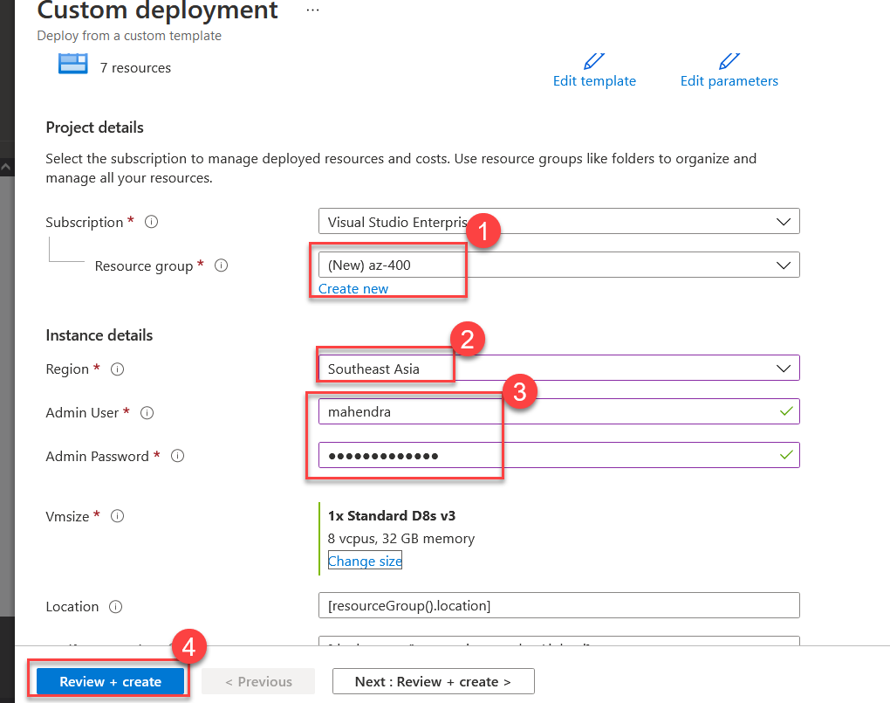

NOTE: You can provide different location like “East US” instead of “Southeast Asia” and Use your own username and password.

1. After you hit review and create, hit “create” button and then wait for the deployment to complete (~15 mins). Your should get following message:

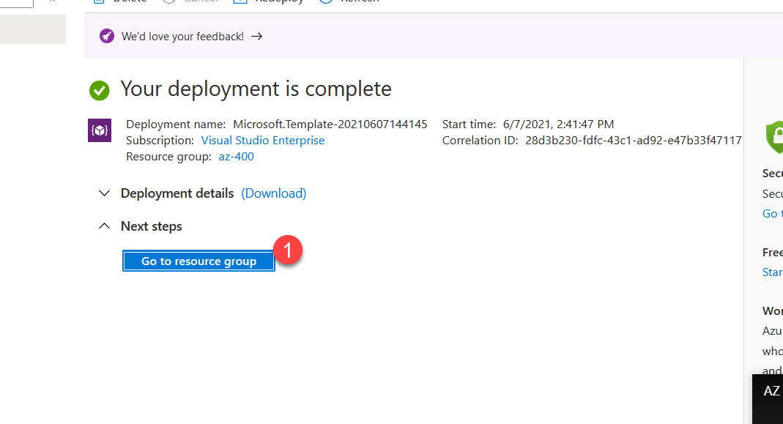

1. After you click “Goto Resource”, you should get list of resources, please choose “VSLab” from the list.

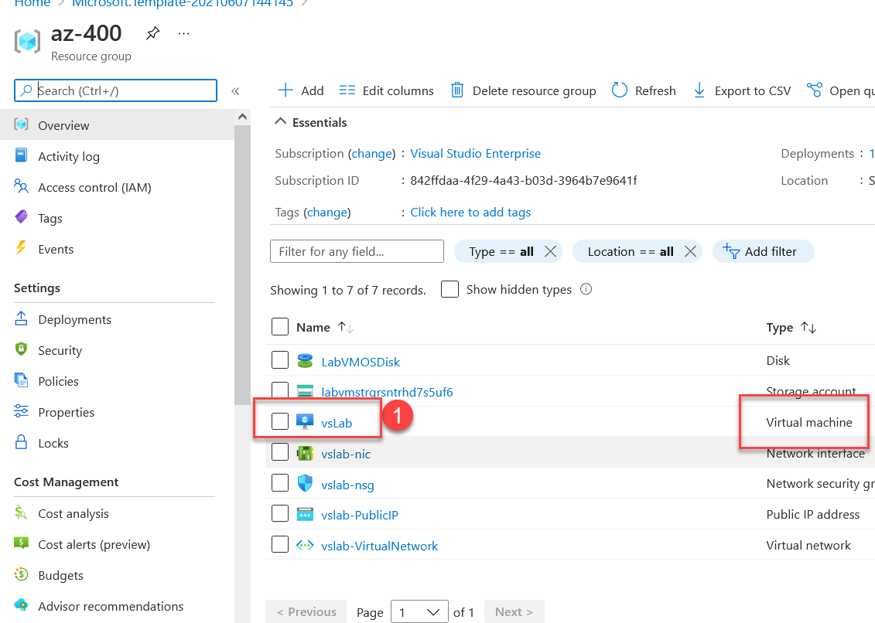

1. Click on “Connect Button” and then choose “RDP”

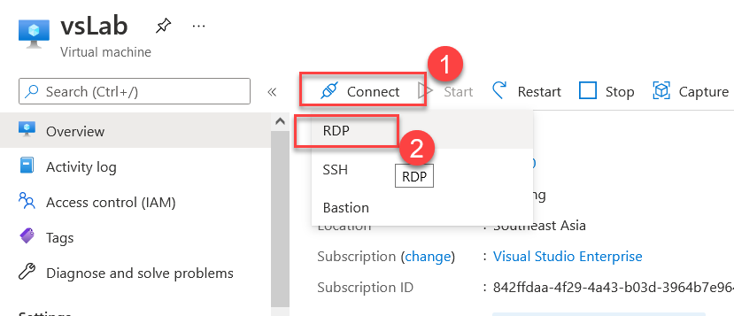

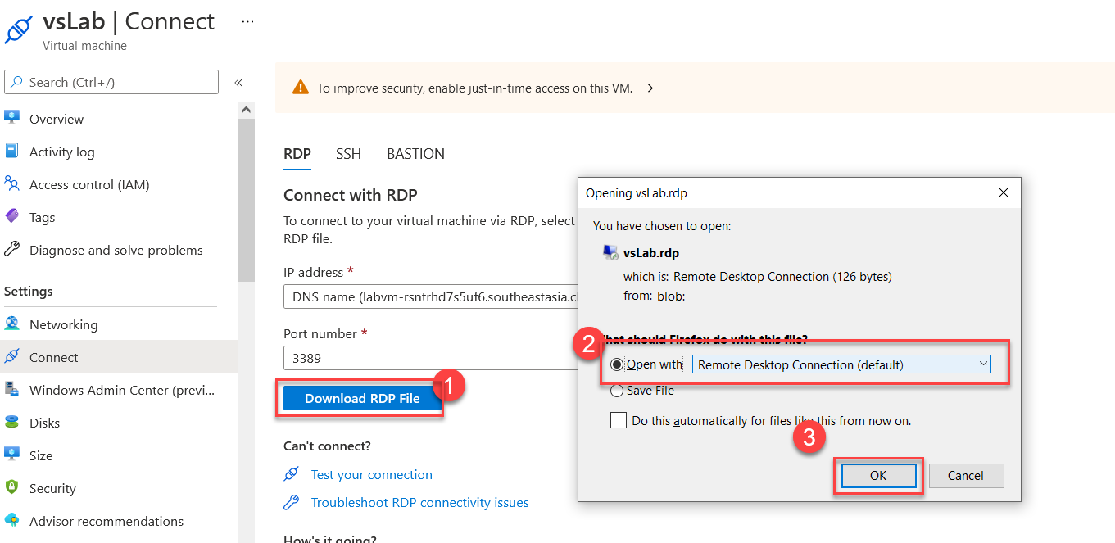

1. Enter User credentials (Use OTHER ) and connect.

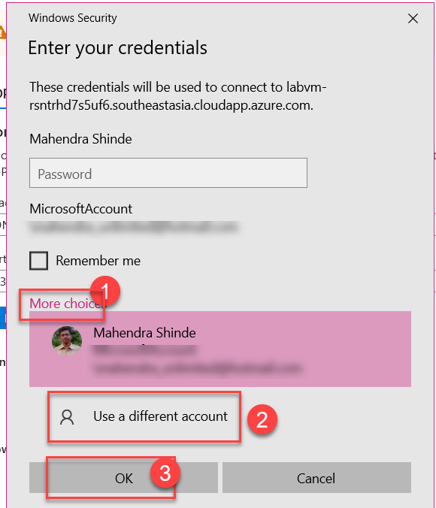

1. Once inside the VM, use “Powershell” to install additional packages.

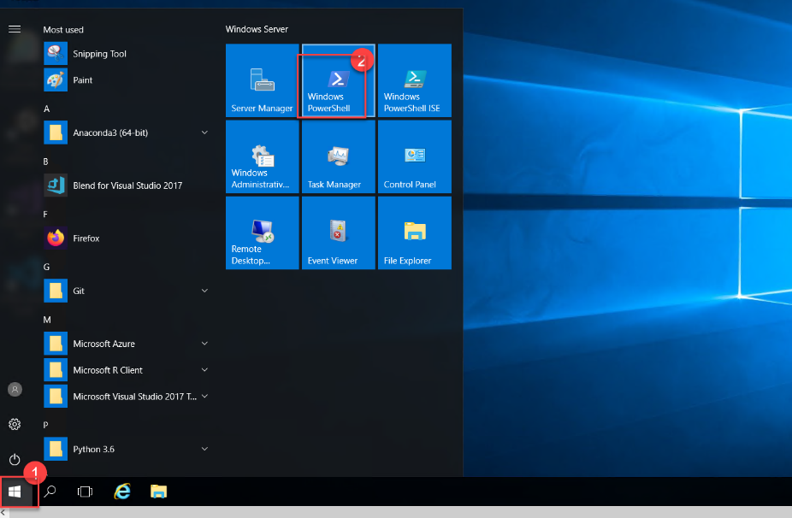

1. Install using following command:

$ choco install firefox 7zip -y

1. From the same remote machine, login into “dev.azure.com” using azure devops credentials

***Use newly installed firefox browser.***

1. From the right top corner, use “User Settings” button to create new Access Token

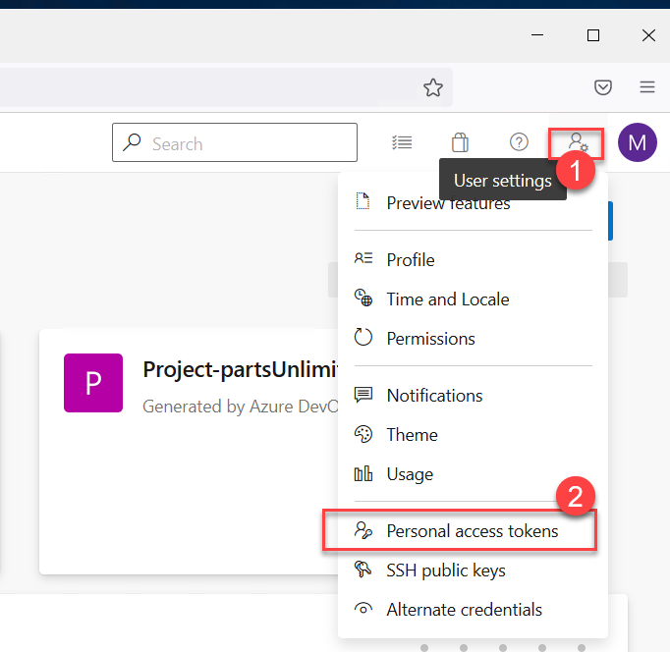

1. Now, make sure you have used option “Show More scopes” at the bottom of screen and then selected permissions: “Read & Manage Agent Pools”

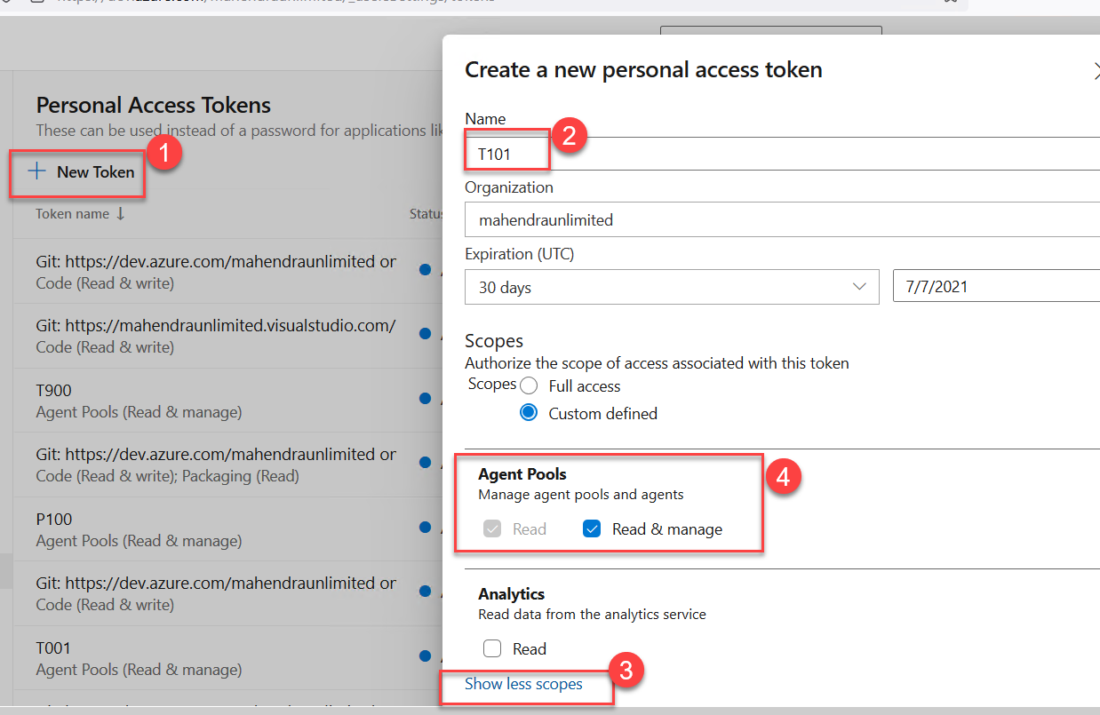

1. After “Create” button is hit, a TOKEN should be generated, please copy it inside new notepad (create text files) to be used in later steps.

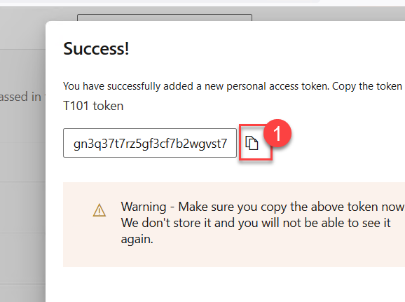

1. Goto “Organization Settings”

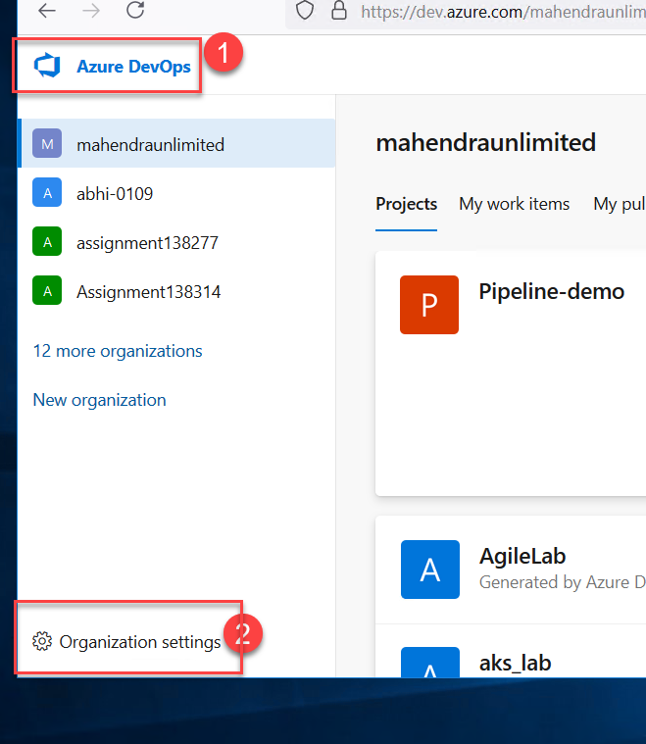

1. Goto “Agent Pools” and then “Default” pool. Click on “New Agent” button

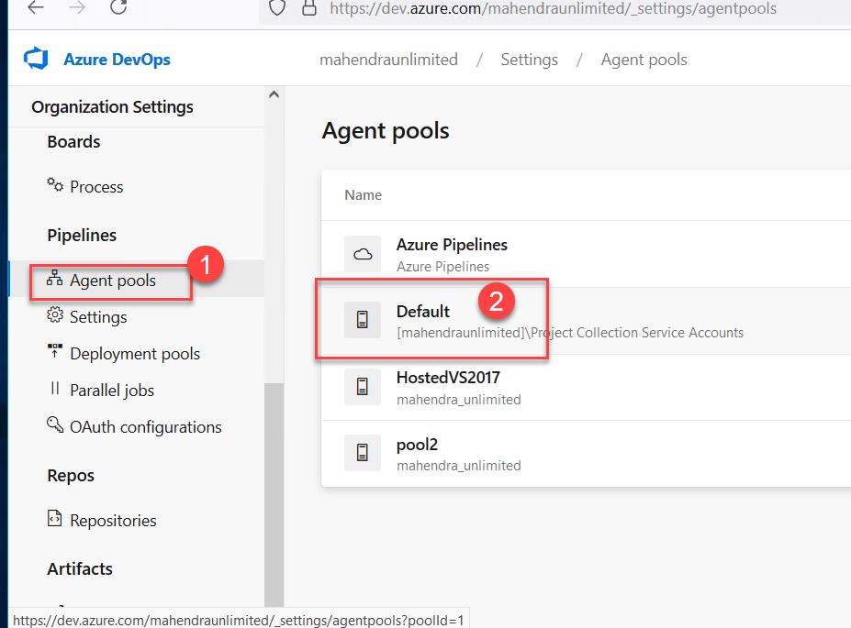

1. Now, Download the agent package for windows

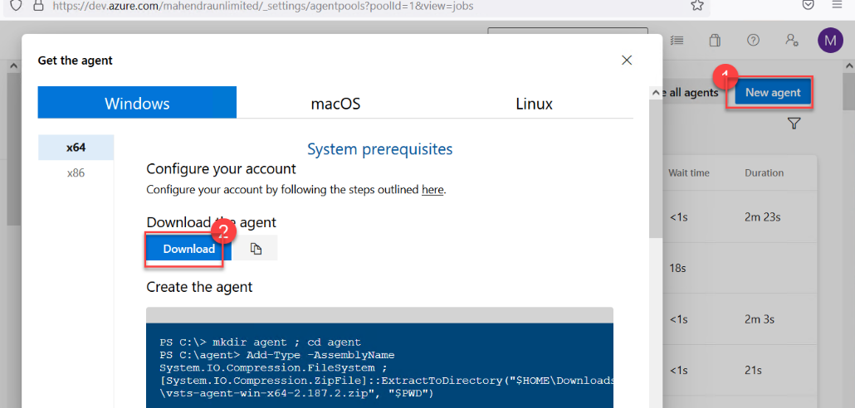

1. File should be now in “downloads” folder, goto “Downloads” folder using “This PC” and then right click and extract using 7Zip

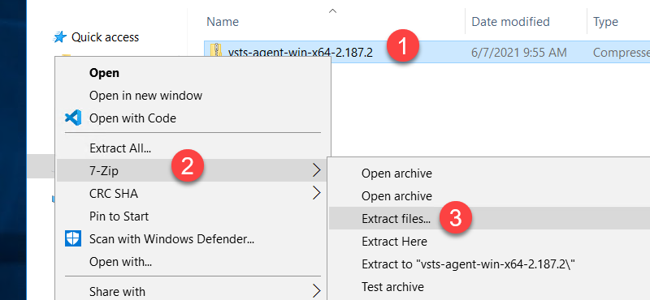

Make sure you extract to “C:\agent” folder and clear the checkbox (step2)

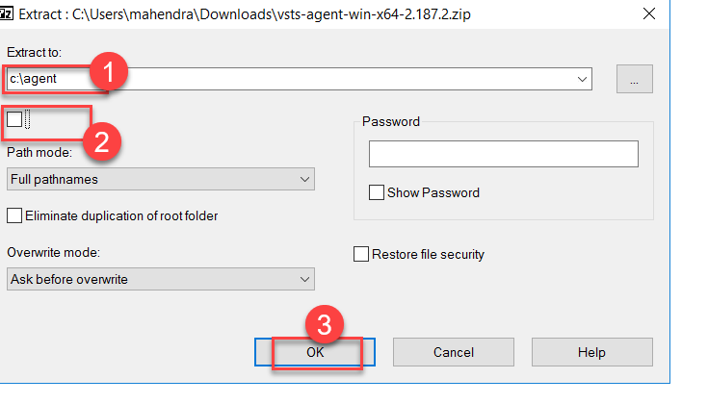

1. After extraction is completed, open C:\agent folder and then launch “config.cmd” (double click to start) Or, open Command prompt and config.cmd from prompt.

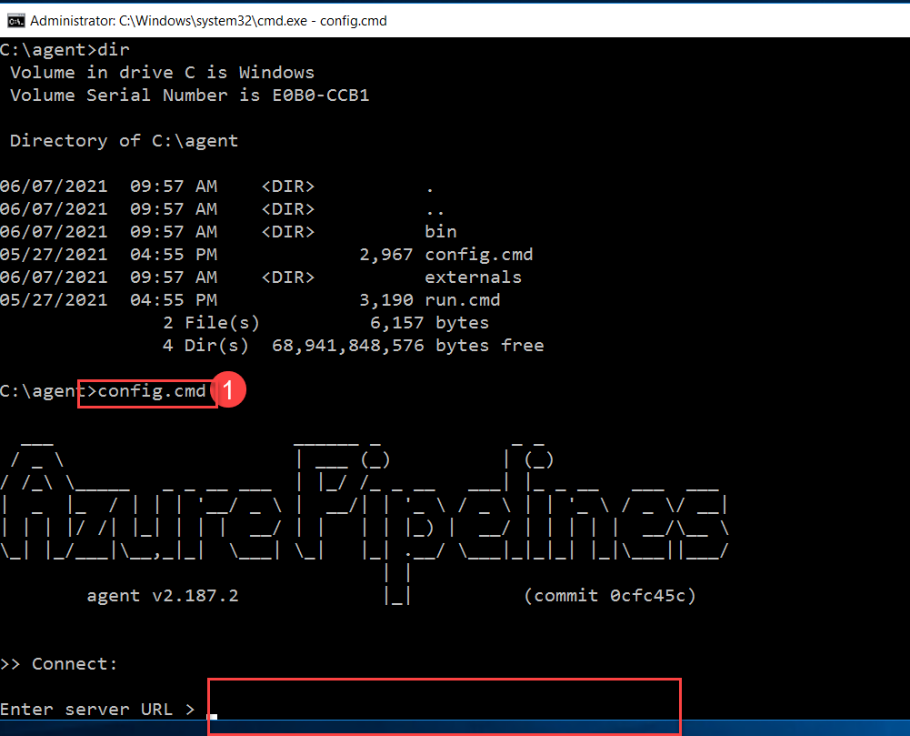

1. Now, you need to provide following inputs:

Server URL : <URL for Your DevOps Account>

Enter Authentication type : <ENTER>

Enter personal access token : <TOKEN from Step#13>

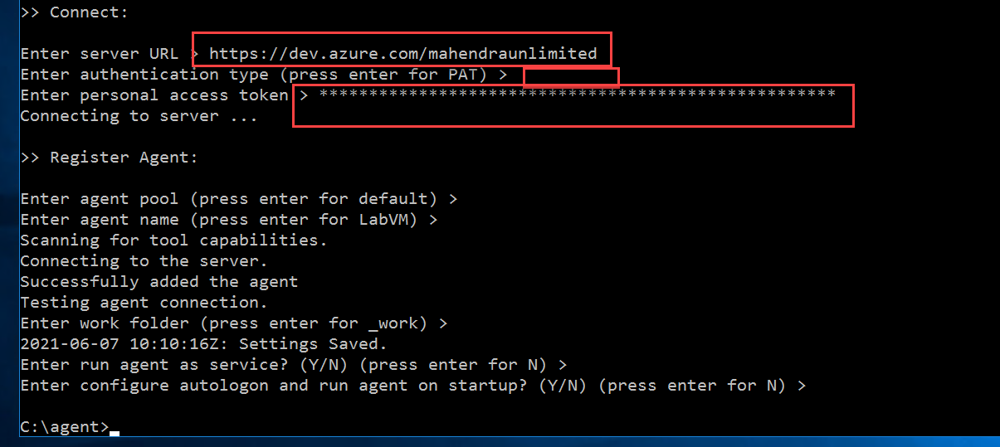

For all other prompts Just press ENTER to accept the defaults!

1. Go back to DevOps Portals (dev.azure.com) > Agent Pools > Default to check if new agent is added (as offline)
2. Start “run.cmd” from agent folder to bring agent “Online”

# Test The New Agent using “Hello World” Pipeline

1. Login into <https://dev.azure.com>
2. Click on “New Project”

Project Name: Demo001

Visibility : Public

1. Goto “Azure Repos” And use 3rd option to INITIALIZE repository with Readme file.

1. Goto “Azure Pipelines” and click “Create Pipeline”

1. Ignore all the other options and use “Classic Editor”

1. Hit “Continue” button to accept the default repository and branch.

1. Select “Empty Job”

1. In Pipeline, select “Default” agent pool

1. Add a command task in “Agent Job1”

1. Use following command instead of the default lines

echo "Hello %USERNAME% from %OS% "

Then Save & Run to start running the pipeline

1. Make sure that, agent pool is “Default” and then click “Save & Run”

1. You should get the response:

